**Assignment -2**

Python DB2

|  |  |
| --- | --- |
| Student Name | Karthik Krishna G |
| Student Roll Number | 1901062 |
| Maximum Marks | 2 Marks |

**Question-1:**

Create User table with user with email, username, roll number, password.

**Solution:**

CREATE TABLE register (

Name VARCHAR (32) NOT NULL,

RollNo VARCHAR (32) NOT NULL,

Email VARCHAR (32) NOT NULL,

Password VARCHAR (32) NOT NULL)

**Question-2:**

Perform UPDATE, DELETE Queries with user table.

**Solution:**

**INSERT INTO register VALUES ('Karthik','1901062','karthik@gmail.com','kk@001');**

**INSERT INTO register VALUES ('Dilip','1901035','dilip@gmail.com','dili@002');**

**INSERT INTO register VALUES ('Ananda','1901011','ananda@gmail.com','Anand@003');**

**INSERT INTO register VALUES ('Kugaanesan','1901068','kuga@gmail.com','kuga@004');**

**UPDATE register SET Name='Anand' WHERE RollNo='1901011';**

**DELETE FROM register WHERE RollNo='1901011';**

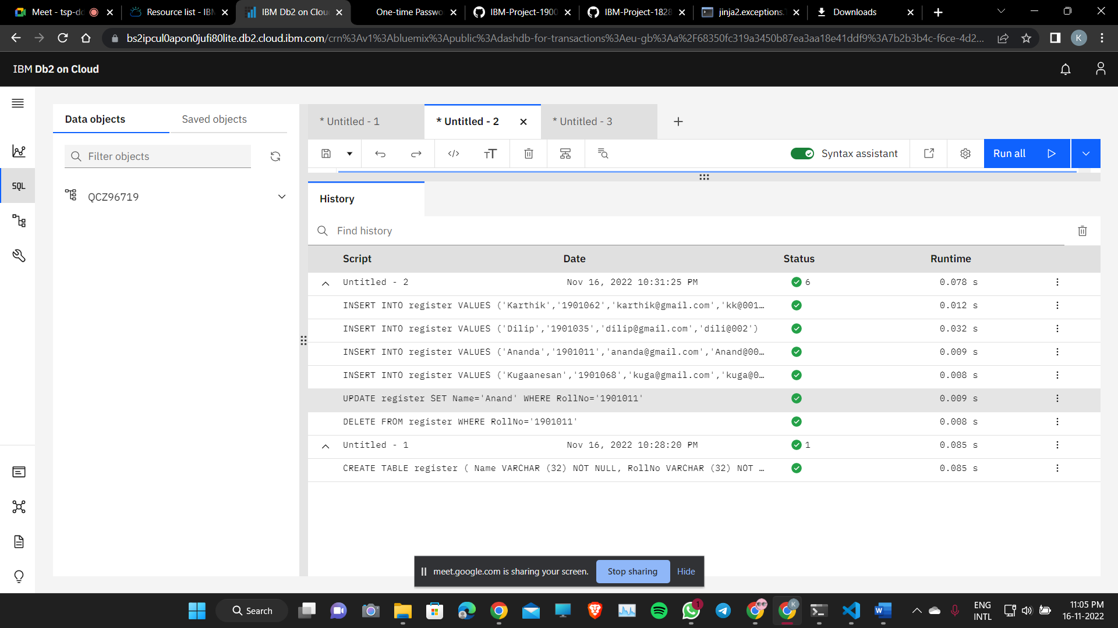

**Question-3:**

Connect python code to db2.

**Solution:**

import ibm_db

dsn_hostname = "HOSTNAME"

dsn_uid = "UID"

dsn_pwd = "PASSWORD"

dsn_driver = "{IBM DB2 ODBC DRIVER}"

dsn_database = "DATABASE"

dsn_port = "PORTNUMBER"

dsn_protocol = "TCPIP"

dsn_security = "SSL"

dsn = ( "DRIVER={0};""DATABASE={1};""HOSTNAME={2};""PORT={3};""PROTOCOL={4};""UID={5};""PWD={6};""SECURITY={7};").format(dsn_driver,dsn_database,dsn_hostname,dsn_port,dsn_protocol,dsn_uid,dsn_pwd,dsn_security,)

print(dsn)

try:

conn = ibm_db.connect(dsn, "", "")

print ("Connected to database: ", dsn_database, "as user: ", dsn_uid, "on host: ", dsn_hostname)

except:

print ("Unable to connect: ", ibm_db.conn_errormsg() )



**Question-4:**

Create a flask app with registration page, login page and welcome page. By default, load the registration page once the user enters all the fields store the data in database and navigate to login page authenticate user username and password. If the user is valid show the welcome page.

**Solution:**

**Main.py**

import ibm_db

from flask import Flask, render_template, redirect, request, session

app = Flask(__name__)

app.secret_key='a'

dsn_hostname = "*****"

dsn_uid = "*****"

dsn_pwd = "*****"

dsn_driver = "{IBM DB2 ODBC DRIVER}"

dsn_database = "*****"

dsn_port = "*****"

dsn_protocol = "TCPIP"

dsn_security = "SSL"

dsn = ("DRIVER={0};""DATABASE={1};""HOSTNAME={2};""PORT={3};""PROTOCOL={4};""UID={5};""PWD={6};""SECURITY={7};").format(dsn_driver,dsn_database,dsn_hostname,dsn_port,dsn_protocol,dsn_uid,dsn_pwd,dsn_security,)

try:

    conn = ibm_db.connect(dsn, "", "")

    print ("Connected to database: ", dsn_database, "as user: ", dsn_uid, "on host: ", dsn_hostname)

    @app.route("/",methods=['GET','POST'])

    @app.route("/register",methods=['GET','POST'])

    def register():

        msg = None

        if request.method == 'POST':

            name=request.form['name']

            rollno=request.form['rollno']

            email=request.form['email']

            password=request.form['password']

            select_sql = "Select * from User where email=?"

            stmt = ibm_db.prepare(conn,select_sql)

            ibm_db.bind_param(stmt,1,email)

            ibm_db.execute(stmt)

            user = ibm_db.fetch_assoc(stmt)

            if user:

                msg = "User with this email already exists!"

                return render_template("register.html",msg = msg)

            else:

                insert_sql = "Insert into User Values (?,?,?,?)"

                stmt = ibm_db.prepare(conn,insert_sql)

                ibm_db.bind_param(stmt,1,name)

                ibm_db.bind_param(stmt,2,rollno)

                ibm_db.bind_param(stmt,3,email)

                ibm_db.bind_param(stmt,4,password)

                ibm_db.execute(stmt)

                return redirect("/login")

        return render_template("register.html")

    @app.route("/login",methods=['GET','POST'])

    def login():

        msg = None

        if request.method == 'POST':

            email=request.form['email']

            password=request.form['password']

            select_sql = "Select * from User where email=?"

            stmt = ibm_db.prepare(conn,select_sql)

            ibm_db.bind_param(stmt,1,email)

            ibm_db.execute(stmt)

            user = ibm_db.fetch_assoc(stmt)

            if not user:

                msg = "User with this email does not exist!"

                return render_template("login.html",msg = msg)

            elif user['PASSWORD'] != password:

                msg = "Incorrect Passowrd!"

                return render_template("login.html",msg = msg)

            else:

                session['loggedin'] = True

                session['id'] = user['EMAIL']

                session['username'] = user['NAME']

                return redirect('/welcome')

        return render_template("login.html")

    @app.route("/logout")

    def logout():

        session['loggedin'] = False

        session['id'] = ""

        session['username'] = ""

        return render_template("login.html",msg="Logged out successfully!")

    @app.route("/welcome")

    def welcome():

        return render_template("welcome.html",)

except:

    print ("Unable to connect: ", ibm_db.conn_errormsg() )

if __name__ == '__main__':

    app.run(debug=True)

**Login.html**

<!DOCTYPE html>

<html lang="en">

<head>

    <meta charset="UTF-8">

    <meta name="viewport" content="width=device-width, initial-scale=1.0">

    <link rel="stylesheet" href="{{url_for('static', filename='css/style.css')}}">

    <title>Login Form</title>

</head>

<body>

    <div class="center">

        <h1>Login Form</h1>

        {% if msg %}

            <span>{{msg}}</span>

        {% endif %}

        <form action="/login" method="POST">

            <div class="inputbox">

                <label for="email">Email</label>

                <input type="text" name="email" required>

            </div>

            <div class="inputbox">

                <label for="password">Password:</label>

                <input type="password" name="password" required>

            </div>

            <button type="submit">Submit</button>

            <button type="reset">Cancel</button>

        </form>

        <span>Don't have an account? <a href="/register">Sign Up</a></span>

    </div>

</body>

</html>

**Register.html**

<!DOCTYPE html>

<html lang="en">

<head>

    <meta charset="UTF-8">

    <meta name="viewport" content="width=device-width, initial-scale=1.0">

    <link rel="stylesheet" href="{{url_for('static', filename='css/style.css')}}">

    <title>Registration Form</title>

</head>

<body>

    <div class="center">

        <h1>SignIn Form</h1>

        {% if msg %}

            <span>{{msg}}</span>

        {% endif %}

    <form action="/register" method="POST">

            <div class="inputbox">

                <label for="email">Name</label>

                <input type="text" name="name" required>

            </div>

            <div class="inputbox">

                <label for="rollno">Roll No</label>

                <input type="text" name="rollno" required>

            </div>

            <div class="inputbox">

                <label for="email">Email</label>

                <input type="email" name="email" required>

            </div>

            <div class="inputbox">

                <label for="password">Password</label>

                <input type="password" name="password" required>

            </div>

            <button type="submit">Submit</button>

            <button type="reset">Cancel</button>

        </form>

        <span>Already have an account? <a href="/login">Login</a></span>

    </div>

</body>

</html>

**Welcome.html**

<!DOCTYPE html>

<html>

    <head>

        <meta charset="UTF-8">

        <meta name="viewport" content="width=device-width, initial-scale=1.0">

        <title>Welcome Page</title>

    </head>

    <body>

        <h1>Welcome {{session['username']}}!</h1>

        <br>

        <a href="/logout">Logout</a>

    </body>

</html>

**REGISTRATION FORM**

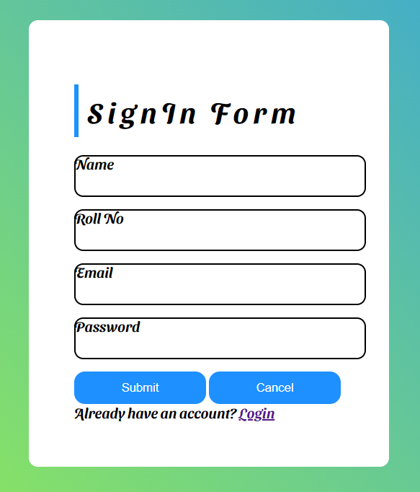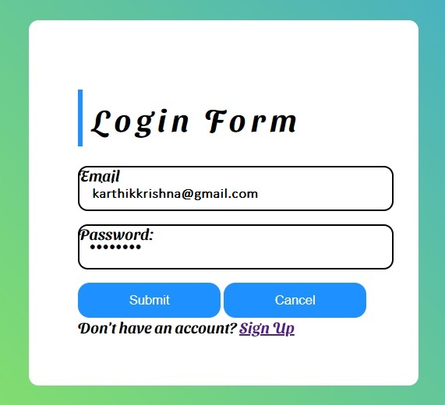

**DB**

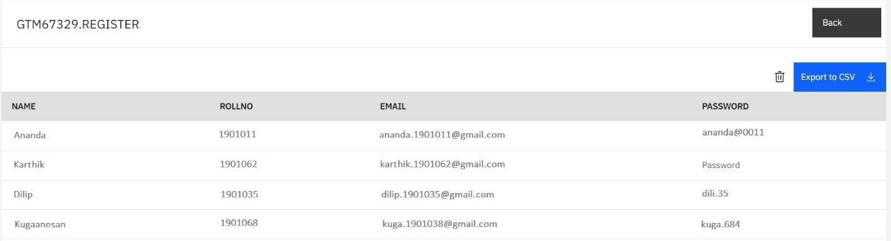

**LOGIN**

**VALID USER**

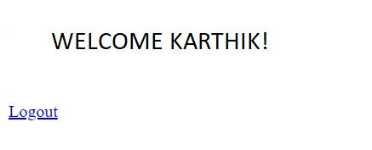

**INVALID USER DETAILS**

